Go to the **VCSS website** 🡪 [**https://vcss.ocfo.gsa.gov/Default.aspx**](https://vcss.ocfo.gsa.gov/Default.aspx)

Click on “**Support Request**” button.

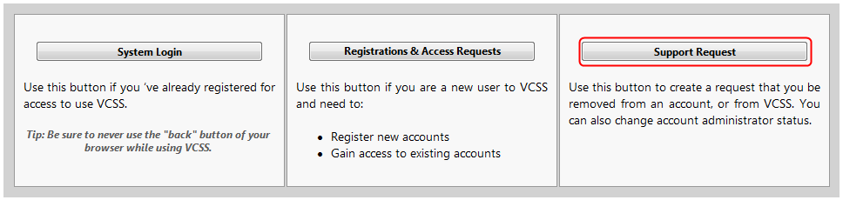

Select “**Change Account Administrator**” in the drop-down menu under “**Topic**,” and fill in the form. Provide a description for your request, enter the alphanumeric code for verification purposes and click “**Submit**.”

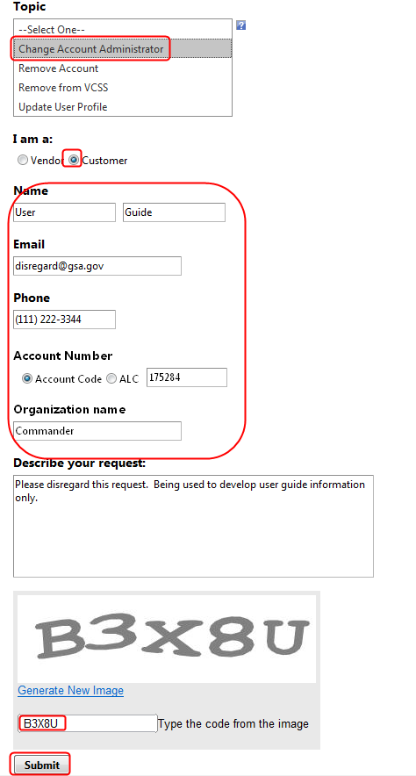

Once you have successfully requested to change your account administrator, you will receive a “Thank-you note” on the website as well as an email. If you do not receive an administrator change notification within two business days, please forward the email to [vcss.security@gsa.gov](mailto:vcss.security@gsa.gov) so that a status update can be provided.

